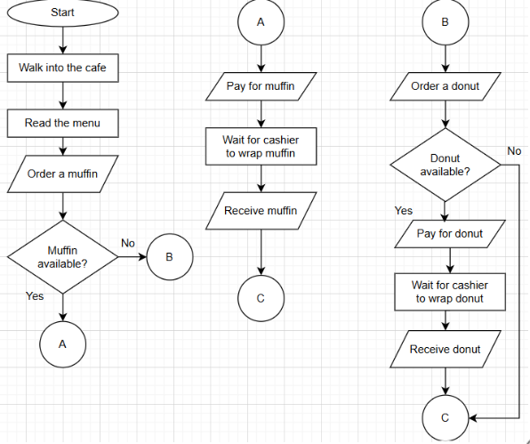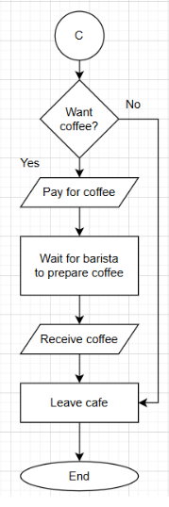

START
//DECLARE muffin optional
//DECLARE donut optional
Walk into the café
Read menu
INPUT muffin
IF muffin available
Pay for muffin
WAIT for muffin to be packaged
OUTPUT receive muffin
ELSE
INPUT donut
IF donut available THEN
Pay for donut
WAIT for donut to be packaged
OUTPUT receive donut
ENDIF
ENDIF
IF want coffee THEN
Pay for coffee
Wait for coffee to be made
OUTPUT receive coffee
ENDIF
Leave cafe
END

Refinement
START
//DECLARE muffin optional
//DECLARE donut optional
Walk into the café
Read menu
INPUT muffin
IF muffin available
Add to bill
ELSE
INPUT donut
IF donut available THEN
Add to bill
ENDIF
ENDIF
IF want coffee THEN
Add to Bill
ENDIF
Pay for orders
IF coffee ordered THEN
//pre-test loop
WHILE coffee is not made
Wait for coffee to be made
ENDWHILE
ENDIF
Package Order items
Receive the order
Leave cafe
END

